**Record Tracking of Meetings**

1.

Meeting Date: 21 Feb 2023

Meeting Venue: The British College, Kathmandu

Meeting Agenda: **Normal Discussion and Initiation of the Team project**

Discussed On:

1. Introduction to team and members
2. Project Name
3. Project Description
4. Leader Deployment
5. Mode of communication

Conclusion:

In concluding the first team meeting, everyone gave their introduction and what they are in specialized. Similarly, team name is decided and name as “CleckFresh Mart”. Everyone studied about the case study and find the motto of the project for what it is done. Karan Chaudhary is elected as the team leader with consensus of every other team member. Communication medium is also selected and Discord was taken into consideration as main medium.

(Members Attended: Sandesh Paudel, Subarna Raj Uprety, Subash Rimal, Karan Chaudhary, Mukesh Bikram Malla)

2.

Meeting Date: 24 Feb 2023

Meeting venue: The British College, Kathmandu

Meeting Agenda: **Task Division and Project Charter Discussion**

Discussed On:

1. Project task division
2. Charter Development

Conclusion:

The meeting concludes after team decided the part for each of the team member and everyone fully agreed with it. For the initiation of the project, a development in project charter is also started.

(Members Attended: Sandesh Paudel, Subash Rimal, Karan Chaudhary)

3.

Meeting Date: 25 Feb 2023

Meeting venue: Virtual Media via Google Meet ([Meet - khf-kbsu-exj (google.com)](https://meet.google.com/khf-kbsu-exj)) at 9 PM

Meeting Agenda: **Project Charter and Team Contract Discussion**

Discussed On:

1. Finalize the Project Charter Development
2. Initiation of Team Contract

Conclusion:

In the first virtual meeting, team finalizes the project charter after understanding the aim of the project. Members were glad to announce the beginning of the project ended in good manner. Everyone was fully excited for upcoming task too. Before concluding the meeting, team contract was thoroughly cited by the team leader which is to be discussed in the following day.

(Members Attended: Subarna Raj Uprety, Subash Rimal, Karan Chaudhary, Mukesh Bikram Malla)

Screenshot of the meeting:

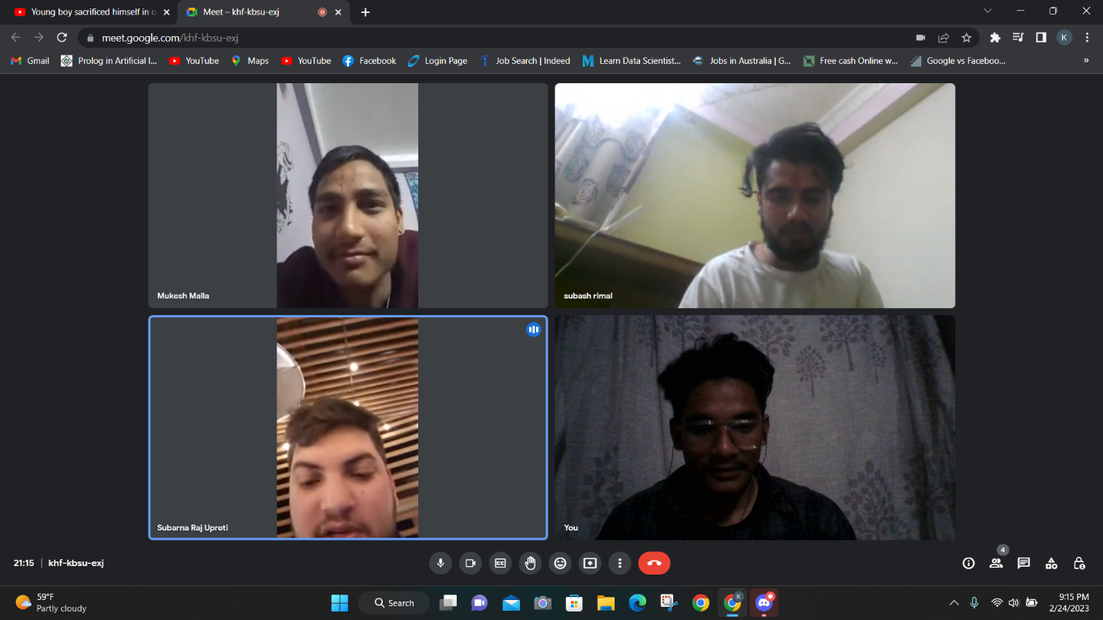

4.

Meeting Date: 26 Feb 2023

Meeting venue: The British College Kathmandu, at 11:00 to 2:30 PM

Meeting Agenda: **Team Contract Discussion**

Discussed On:

1. Overview of team contract
2. Motto and code of conduct for the contract

Conclusion:

The meeting was fully based on team code of conduct from the beginning to completion of the project. Leadership structure was also discussed among the members. Everyone understood the contract deeply and has to applied during the progress. Team members are fully aware of what is the consequences that can happen when a contract is breached.

(Members Attended: Sandesh Paudel, Subarna Raj Uprety, Subash Rimal, Karan Chaudhary)

5.

Meeting Date: 26 Feb 2023

Meeting venue: Virtual Media via Google Meet ([Meet - khf-kbsu-exj (google.com)](https://meet.google.com/khf-kbsu-exj)) at 9 PM

Meeting Agenda: Finalization of Team Contract

Discussed On:

1. Team contract finalization
2. Upcoming steps for the project
3. Github Repository creation

Conclusion:

The last meeting of the initiation part concluded with the completion of team contract. Everyone in the team agreed with the contract and were fully aware of the consequences of breaching it. Team leader thanked everyone for their contribution in the completion of initial part of the project and wished everyone to help furthermore in upcoming days.

(Members Attended: Sandesh Paudel, Subarna Raj Uprety, Subash Rimal, Karan Chaudhary, Mukesh Bikram Malla, Navish Dewan)

Meeting Screenshots:

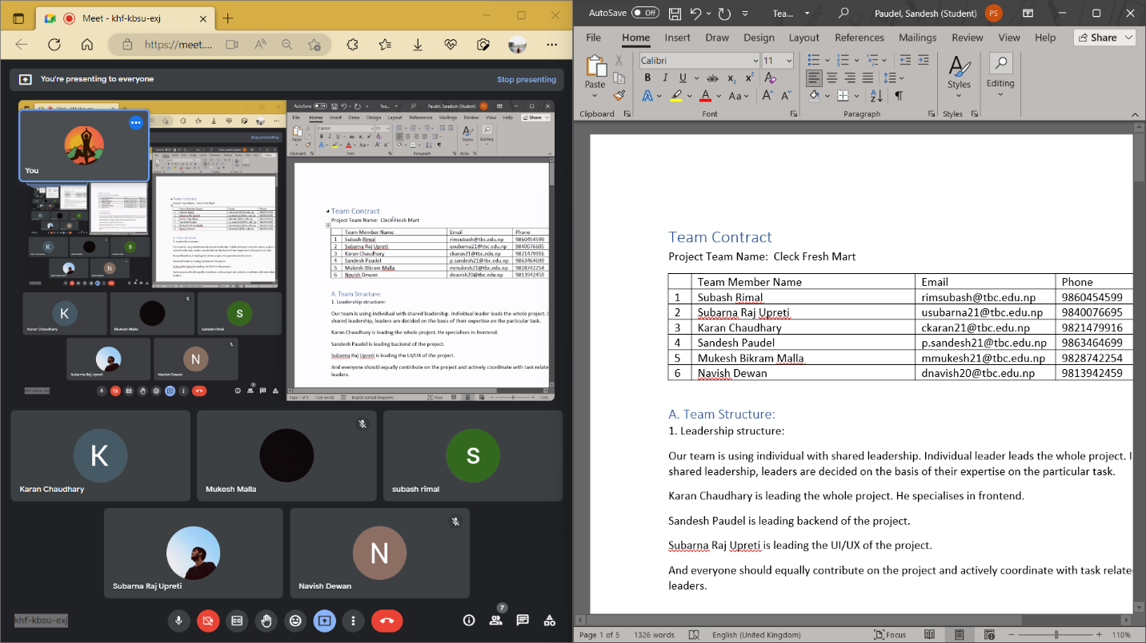

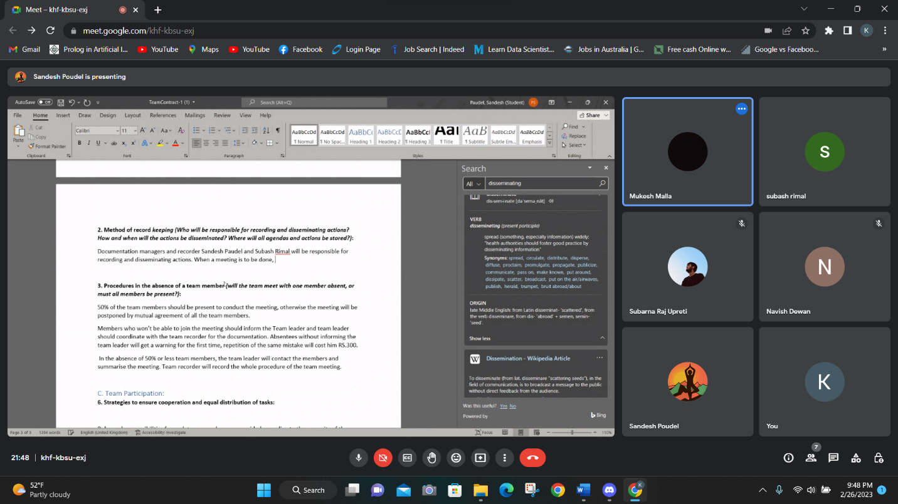

6.

Meeting Date: 27 Feb 2023

Meeting venue: Virtual Media via Google Meet ([Meet - khf-kbsu-exj (google.com)](https://meet.google.com/khf-kbsu-exj)) at 9 PM

Meeting Agenda: Team record and document management

Discussed On:

1. How the documents are managed?
2. Ways to record each team meeting in appropriate way.

Conclusion:

In the day after submitting the team contract in front of project leader, our team sat and discussed about management and recording of the team meeting. Proper attendance of the members is recoded and documents are also managed by documentation manager or recorder. A daily based attendance is recorded in a excel file and other team activities are also managed and recorded by the manager.

(Members Attended: Sandesh Paudel, Subarna Raj Uprety, Subash Rimal, Karan Chaudhary, Mukesh Bikram Malla, Navish Dewan)

Screenshots of the meeting: